Approach Note
Listed, Paid, Rewarded
What should a data-science student learn next? A verified, uncertainty-aware next-skill decision aid built from four datasets
PROJECT TITLE: Skill Investment Intelligence: Measuring What Employers List, Pay, and Reward
PROJECT SUMMARY:
From Listed to Rewarded helps students identify which skills are truly valuable in the job market. It compares coding, mathematics & statistics, AI/ML, big data, and dashboards & storytelling based on demand, salary, and employer rewards. Using statistical analysis and robustness checks, it generates evidence-based Skill Investment Cards with clear recommendations or reports “Not Enough Evidence” when the data is insufficient.

Data Used: Data Science Jobs, Analytics Jobs, JDS Skill Traits, SDS Personality Traits (2024–25 sample data supplied by SAS).
Tools Used: Python (pandas, statsmodels, scikit-learn) for preparation and modelling; SAS Viya for Learners (VisualAnalytics, Model Studio) for reporting and model comparison
Team: Aavishkar Hacks
LEAD: SACHIN PUNETHA
YATHARTH DAHIYA
JAYANT KUMAR BANA
SHIVAM RAWAT

.

Contents
Executive summary 3
1. Problem definition and analytics objective 4
1.1 Context 4
1.2 Who decides what 4
1.3 Core question and objectives 4
1.4 Hypotheses 5
1.5 Scope 5
1.6 What success looks like 5
2. Approach 5
2.1 Overall flow 5
2.2 Design principles 6
2.3 Why each method 6
2.4 Verification framework 7
2.5 Tools and reproducibility 7
3. Data exploration and preparation 8
3.1 What the four files actually are 8
3.2 Data issues found and how each was handled 8
3.3 Analytics Jobs: salary, experience and location 9
3.4 Separating data roles: a validated filter 9
3.5 Data Science Jobs: the title ladder 10
3.6 What employers list 11
3.7 Linking posting skills to the five junior skill areas 12
3.8 Junior and senior files 12
4. Data analysis 13
4.1 Market price: what the market pays 13
4.2 Internal reward: what one company rewards 16
4.3 The bridge: Listed vs Paid vs Rewarded 17
4.4 Senior profile: career-stage contrast and a label check 19
4.5 The Skill Investment Card 20
5. Results and conclusions 22
5.1 Answer to the core question 22
5.2 Hypotheses 22
5.3 Conclusions 22
6. Implications 23
6.1 For students and early-career analysts 23
6.2 For universities 23
6.3 For employers and recruiters 23
6.4 Limitations 24
6.5 Next steps 24
6.6 References 24
Appendix 25

Executive summary
Students decide what to learn from skill lists and headline demand figures. Those show what employers list, not what the market pays once you compare like-for-like jobs, and not what an employer rewards after hiring. We linked all four supplied datasets to measure those three things for five skill areas — coding, maths & statistics, AI/ML, big data, and dashboards & storytelling — and turned the results into a Skill Investment Card that recommends a next skill with an interval, or says "not enough evidence".
Every step was verified before the next began: assertions on the data, known-answer tests on the statistical methods, null tests, and robustness checks. The main findings:
- AI/ML is the most hyped skill but carries no salary premium at entry level. Among postings needing 0–3 years, AI/ML has an odds ratio of 0.99 [0.74, 1.33] for a higher salary band once experience, city and role family are controlled. Its large raw premium mostly reflects that ML jobs sit in better-paid role families.
- Coding pays, everywhere. Coding is worth about +12.5% in salary [+8.1%, +17.0%] within the same role family, survives all three skill-mapping versions, and is strongest at entry level (odds ratio 1.89).
- Maths & statistics is what one company rewards most. For junior data scientists, it is the strongest predictor of a high salary hike (odds ratio 4.6 per standard deviation, BCa interval [2.0, 9.9]; ranked first in 65% of 2,000 resamples), yet the market premium for it is modest. This is the clearest "rewarded more than paid" gap.
- Dashboards & storytelling are rewarded inside, not paid extra outside. The apparent market penalty (odds ratio 0.65) is an artefact of Excel/MIS reporting jobs: with core visualisation tools only (Tableau, Power BI, Qlik), the penalty disappears, and at entry level those tools carry a premium (1.61).
- Your weakest skill says more than your strongest. Among juniors, the weakest of five scores predicts a high hike far better than the strongest (AUC 0.85 vs 0.59; difference 0.26 [0.18, 0.35]). Spread itself does not matter once the overall level is known — the lesson is "no weak area", not "be a generalist".
- The senior success label can be reproduced almost exactly from the trait scores (one cut-off on the total score is 92.5% accurate; a penalised curved model reaches cross-validated AUC 0.998). We report this as a finding about how the label was built, not as a strong model of real-world success.
The Skill Investment Card passes six tests (including zero monotonicity violations in 1,000 random profiles) and abstains for profiles outside the data. For example, a final-year student strong in coding but weak in statistics and storytelling is advised to invest in maths & statistics first (best option in 89% of uncertainty draws).

1. Problem definition and analytics objective

1.1 Context
Demand for analytics skills in India is real but uneven across career stages. Naukri's JobSpeak index for May 2026 reported AI/ML hiring up 22% year on year against 7% for fresher hiring, with fresher growth driven mainly by customer-facing roles [1]. Headlines like these, together with recruiter and edtech skill lists, are what students use to choose what to learn. They describe demand — how often a skill is asked for — but not price (what it adds to pay in a comparable job) or reward (what an employer actually pays more for after hiring).
SAS supplied four 2024–25 sample datasets that, for the first time in one place, cover all three: job postings with skills and salary bands (Analytics Jobs), company-level salary summaries by title (Data Science Jobs), measured skills and salary-hike outcomes for junior data scientists (JDS), and personality traits and success outcomes for senior data scientists (SDS).

1.2 Who decides what
Primary user: a final-year student or early-career analyst (0–3 years) deciding where the next six months of learning go — deeper modelling, maths and statistics foundations, data engineering, or communication. Secondary readers: universities designing curricula and employers writing job descriptions. Hiring managers screening candidates are explicitly not a target user (see scope).

1.3 Core question and objectives
Core question: Which skills does the market pay for, which does a company reward, where do the two disagree — and how sure are we?

Table 1. Analytics objectives and how each is delivered.

# | Objective | Data | Deliverable
O1 | Market price: estimate each skill's salary premium within role family, controlling for experience and city; compare 0–3 vs 5+ years | Analytics Jobs | Premium waterfall; career-stage contrast
O2 | Internal reward: estimate how each junior skill relates to a high salary hike, with bootstrap intervals | JDS | Ranked skill effects with BCa intervals
O3 | Bridge: map the five junior skill areas to posting skills and compare Listed vs Paid vs Rewarded | Analytics Jobs + JDS | Three-axis comparison, verdict per area
O4 | Senior profile: test curved personality effects and whether the label is reproducible from the scores | SDS | Model with permutation test and label check
O5 | Decision aid: a scorecard that ranks the next skill with an interval and abstains when evidence is thin | All | Skill Investment Card + tests

1.4 Hypotheses
Table 2. Hypotheses fixed before modelling.
 | Hypothesis (stated before analysis) | How it is tested
H1 | The skills listed most often are not the ones with the largest within-role salary premium | Listed share vs ordinal-model premium (§4.1)
H2 | What pays at entry level differs from what pays at 5+ years | Separate models by experience band (§4.1.4)
H3 | The market price and the internal reward of a skill area disagree for at least one area, robustly | Disagreement must hold under ≥2 of 3 crosswalks (§4.3)
H4 | Senior success is related to personality in a curved (non-linear) way | Linear vs quadratic models; permutation test; label check (§4.4)

1.5 Scope
In scope: the four supplied files; association-level findings; Indian postings. Out of scope: causal claims ("learning X causes a raise"), any tool for screening candidates by skill or personality, salary forecasts beyond the data period, and any external data in the analysis (the Naukri figure above is context only, consistent with the no-data-transfer rule).

1.6 What success looks like
- Skill premiums that survive role-family control, shown as a waterfall: raw → experience and city → role family.
- A Listed vs Paid vs Rewarded comparison with intervals and a verdict that survives alternative skill mappings.
- A senior result reported with a permutation test and a label-construction check, not just an AUC.
- A scorecard whose recommendations carry intervals and abstain outside the data's support.
- Every data fix logged with its row count and its measured effect on results.

2. Approach

2.1 Overall flow
Figure 1 shows the pipeline. Three questions — what is listed, what is paid, what is rewarded are answered from different files, then joined through a skill-area crosswalk and turned into a decision aid. The senior file is used as a career-stage contrast.
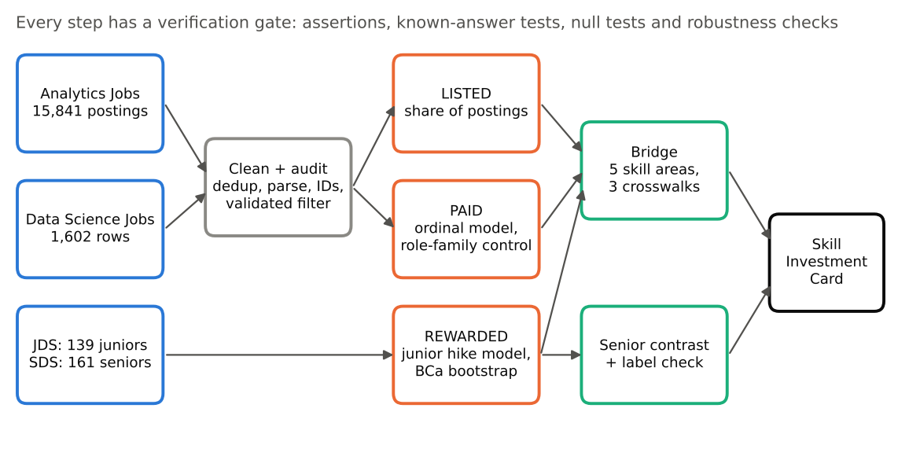
Figure 1. Analysis flow. Blue = source data, grey = preparation, orange = the three measurements, green = synthesis, black = the student-facing output.

2.2 Design principles
- Compare like with like. A skill can look valuable only because it appears in senior or specialist jobs. Every market premium is therefore reported after controlling for experience, city and role family.
- Show uncertainty everywhere. The junior and senior files are small (139 and 161 rows). Every estimate carries an interval; performance is cross-validated and repeated; small-sample intervals use the bias-corrected and accelerated (BCa) bootstrap.
- Verify each step before using it. No step feeds the next until its checks pass (Section 2.4).
- Abstain rather than guess. The decision aid says "not enough evidence" when the student's profile is outside the data or two options are statistically tied.

2.3 Why each method
Table 3. Method choices and their justification.
Question | Method | Why this method
Market price (O1) | Proportional-odds ordinal logistic regression on salary band | Salary in Analytics Jobs is six bands (0–3 … 25–50 LPA), not a number; ordinary regression on band mid-points would invent precision
Robustness of O1 | Interval regression on log-salary using band edges | Gives a % premium and checks the result does not depend on the ordinal model
Many skills at once | Benjamini–Hochberg false-discovery control (q < 0.10) | 64 skills tested; without correction several "premiums" would be chance
Internal reward (O2) | Logistic regression on standardised scores; 5-fold CV × 20 repeats; BCa bootstrap (2,000) | n = 139: point estimates alone mislead; repeated CV gives honest AUC; BCa corrects small-sample bias
Is the signal real? | Permutation test (500 label shuffles) | Gives a p-value for the cross-validated AUC itself
Bridge (O3) | Three crosswalk versions; disagreement must hold in ≥2 of 3 | Mapping posting keywords to five areas is a judgement; the verdict must not hinge on it
Senior (O4) | Linear vs quadratic logistic; ridge penalty when the fit separates; label reproduction test | Tests curvature while guarding against an over-fitted or mechanically constructed label
Decision aid (O5) | Bootstrap draws of reward × market estimates, mixed over crosswalks | Turns both uncertainties into an interval and a "probability this is the best option"

2.4 Verification framework
Five kinds of check are used throughout: assertions (the data is what we think — e.g. exactly 14,840 rows after de-duplication), sanity checks (results match known patterns — salary rises with experience), known-answer tests (plant a true effect in simulated data and confirm the method recovers it), null tests (shuffle the signal away and confirm the effect vanishes), and robustness checks (re-run with an alternative reasonable choice). Before touching real results, each core method was tested on simulated data with a known answer (Table 4).
Table 4. Known-answer tests run before the real analysis.
Test | Set-up | Result | Verdict
Ordinal regression on banded salary | 200 simulations, n = 2,700, true premium 0.25 log-points, banded at the real cut points | Mean estimate 0.251; 95% CI coverage 98% | Pass
Bootstrap intervals, n = 139 | 60 simulations × 400 resamples on the real JDS scores with planted effects | Coverage 0.87–0.97; slight under-coverage for the largest effect | Pass, with BCa adopted
Permutation test | 200 null datasets; one real-signal dataset | 2% false positives (conservative); real signal p = 0.002 | Pass
Benjamini–Hochberg | 300 runs, 40 null + 10 real p-values, α = 0.10 | Observed false-discovery rate 0.075 | Pass
Curvature test (senior) | 200 simulations without and with a planted curve | False-positive rate 6%; power 96% | Pass

2.5 Tools and reproducibility
Cleaning and modelling are in Python (pandas, statsmodels 0.15, scikit-learn) with a fixed random seed (2026) and raw-file hashes recorded at the start of every run. Every chart is saved with the table it plots, and every number in this report is read from those output files. The cleaned files are exported as flat CSVs for SAS Viya for Learners, where the reporting layer (SAS Visual Analytics) and the model comparison (SAS Model Studio pipelines: logistic regression, decision tree, forest, gradient boosting on the same folds) are built; the steps are listed in Appendix E.

3. Data exploration and preparation

3.1 What the four files actually are
Table 5. Inventory of the four files, as verified on load.
File | Rows | One row is… | Key fields | Outcome
Data Science Jobs | 1,602 | a company × job-title summary (not a posting) | 642 companies, 10 titles, min experience, min/avg/max salary ("7.8L"), number of postings | —
Analytics Jobs | 15,841 | one job posting | experience ("6-10 yrs"), designation, key skills, location, salary band | salary band (6 levels)
JDS Skill Traits | 139 | one junior data scientist | 5 skill scores, 1–5 | high / low salary hike (52.5% high)
SDS Personality Traits | 161 | one senior data scientist | Big Five trait scores (17–68) | high / low success (52.8% high)

Three facts about these files shaped the whole analysis. First, Analytics Jobs salary is banded, so the market model must be ordinal. Second, Data Science Jobs has no skills and no city: skill premiums can only come from Analytics Jobs, and the "93,005 postings" sometimes quoted for this file is the sum of its num_of_jobs column, not a row count. Third, the junior and senior files describe one company each, so their findings are a case study of one employer, not "what companies reward".

3.2 Data issues found and how each was handled
Table 6. Audit log summary. Each fix was re-run with the fix undone to measure its effect.
Issue found | Rows | Handling | Measured effect on results
Exact duplicate postings (ignoring the ID column) | 1,001 | Removed | Coding OR 1.331 → 1.482; dashboard 0.698 → 0.645; others within ±0.07
Most postings are not data roles (Oracle, Java, SEO, accounting…) | 11,691 | Validated data-role filter (§3.4) | Versus a title-only filter: maths & stats OR 1.076 → 1.197, coding 1.388 → 1.482
Non-India locations (Canada, Dubai, UAE, US…) | 23 data roles | Excluded | All area ORs change by ≤ 0.01
City spellings (Bangalore/Bengaluru, Gurgaon/Gurugram, Delhi/Delhi NCR, area suffixes) | 928 raw tokens | Normalised; first city = primary; 16% multi-city flagged | All area ORs change by ≤ 0.01
Skill lists truncated with "..." | 87% of rows | Trailing dots stripped; truncation flag; re-check on complete lists | Same direction for all five areas (§4.1.5)
job_type mostly missing, inconsistent case | 78% missing | Not used | None
reference_no reused by different companies (DS Jobs) | 276 | Kept; surrogate row key | None (no joins on it)
Implausible values in DS Jobs (min exp ≥ 15; avg salary < 2 LPA) | 3 + 12 | Flagged, kept | Experience slope 16.51% → 16.01% per year without them
IDs reused with different values (JDS / SDS) | 4 / 18 | Kept; surrogate row key | CV AUC with/without: junior 0.905 / 0.898; senior 0.963 / 0.952
Stray spaces in SDS column names (" extraversion") | 2 columns | Stripped | None (prevents broken joins and SAS imports)
Inconsistent rows (≥10 yrs experience in 0–3 LPA band, etc.) | 11 | Logged, kept | Negligible

3.3 Analytics Jobs: salary, experience and location
Experience strings ("6-10 yrs") parse cleanly for all 14,840 rows (minimum ≤ maximum in every row). Salary bands rise steadily with experience (Figure 2): 56% of postings asking for 0–1 years sit in the lowest band, while 33% of 9+ year postings sit in the top band. This monotone pattern is the main sanity check that the salary and experience fields mean what the dictionary says.
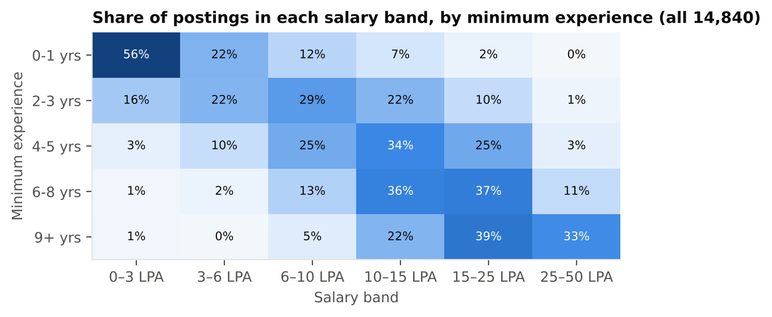
Figure 2. Salary band by minimum experience (all de-duplicated postings). Rows sum to 100%.
Locations hold 928 distinct raw tokens, mostly spelling variants and area suffixes such as "Bengaluru(Whitefield)". After normalisation, the seven largest cities cover most data-role postings (Bengaluru 861, Mumbai 408, Gurugram 368, Delhi NCR 303, Pune 221, Hyderabad 168, Chennai); the rest are grouped as "Other" in the models.
Truncation is the most important limitation of this file. 87% of skill lists end in "...", so we observe only the first few skills a recruiter typed. A skill being absent therefore does not mean the job does not need it. We treat each skill flag as "named among the first listed skills" and re-check every market result on the 500 data-role postings with complete lists.

3.4 Separating data roles: a validated filter
Analytics Jobs mixes data roles with software, finance, marketing and operations jobs. Every downstream number depends on which postings count as data roles, so the filter was built and tested like a model. We drew random samples, labelled each posting by reading its title and skills (rule: is the core work analysing data, statistical or ML modelling, data engineering, or BI/reporting?), and scored the filter against those labels. Targets were set in advance: precision ≥ 0.90 and recall ≥ 0.80.
Table 7. Data-role filter validation. Round 3 used a sample the rule had never been tuned on.
Round | Sample | TP | FP | FN | Precision | Recall | What it taught us
1: title keywords only | 200 random | 35 | 4 | 8 | 0.90 | 0.81 | Misses SAS, Power BI, MSBI, data-modelling titles; catches data-entry, SEO, sales
2: refined title rule | 200 fresh | 30 | 1 | 11 | 0.97 | 0.73 | Misses ETL/Hadoop engineers and credit-risk modelling titles
3: title OR ≥3 core skills (final) | 200 untouched | 48 | 4 | 11 | 0.92 | 0.81 | Passes both targets; tuned on rounds 1–2 only

The final rule keeps a posting if its title matches data-role terms or it lists at least three core data skills, and it excludes data-entry, sales, SEO and administrator titles. It keeps 3,149 postings, of which 3,126 are in India (Figure 3). A second check on 100 random kept postings found 95 genuine data roles, consistent with the measured precision.
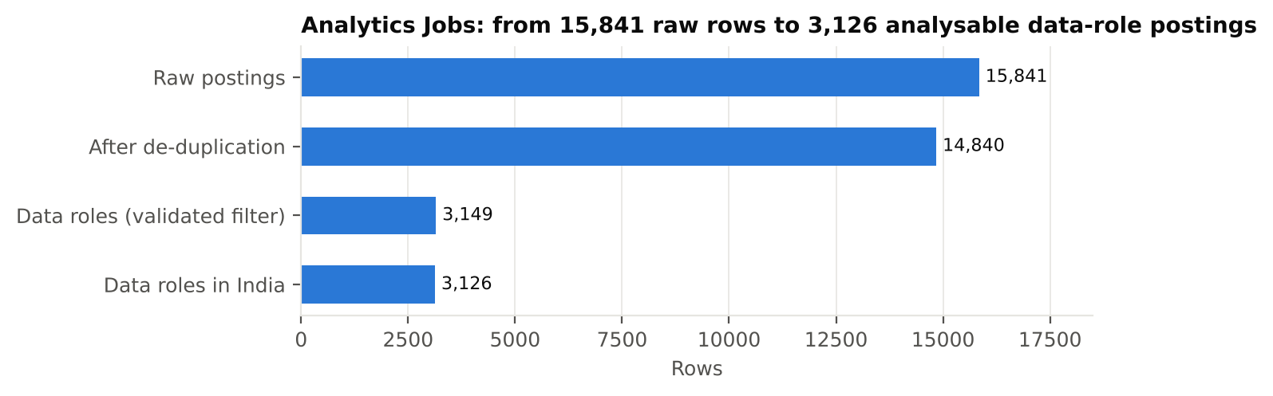
Figure 3. From 15,841 raw rows to 3,126 analysable data-role postings in India.
Each kept posting is assigned to one of six role families by title (falling back to core skills when the title is silent). A blind check on 95 data roles found 90.5% agreement (target ≥ 85%); most disagreements were genuinely ambiguous titles such as "Big Data Analyst". Role family is the key control in the market model, because pay differs sharply by family (Table 8, Figure 4).
Table 8. Role families among the 3,126 data-role postings.
Role family | Postings | Median salary band | Median min. experience (yrs)
Data Analyst / Analytics | 842 | 6–10 LPA | 3
Data Scientist / ML | 719 | 10–15 LPA | 4
Data Engineer | 526 | 10–15 LPA | 5
Analytics Manager | 451 | 15–25 LPA | 7
BI / Reporting | 429 | 6–10 LPA | 3
Risk & Credit Modelling | 159 | 10–15 LPA | 5

The salary mix differs sharply between families (Figure 4). One in five BI/Reporting postings sits in the lowest band (0–3 LPA), against 2% of Analytics Manager postings, 21% of which reach the top band. This is why a skill that is common in BI/Reporting jobs can look "penalised" unless role family is controlled.
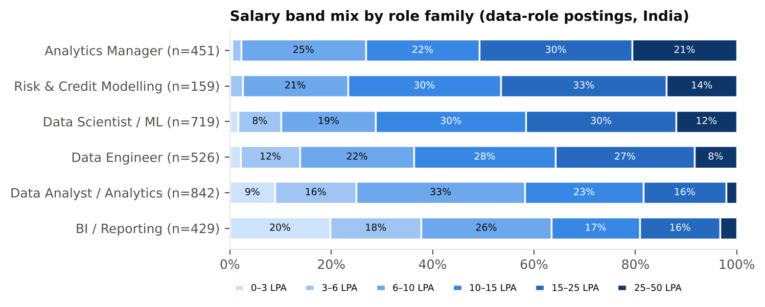
Figure 4. Salary band mix by role family, data-role postings in India.

3.5 Data Science Jobs: the title ladder
Data Science Jobs summarises 93,005 postings across 642 companies and ten titles. It is concentrated: the ten largest employers account for 35% of postings. Weighted by postings, median average salary climbs from ₹4.9L for Data Analysts to ₹20.2L for Senior Data Scientists and ₹20.5L for Data Architects (Figure 5). Within each title family the "Senior" version pays 57–72% more, and a weighted regression with title controls gives +16.5% salary per year of minimum experience [14.7%, 18.4%]. Removing the 15 flagged rows changes this by half a point (16.0%).
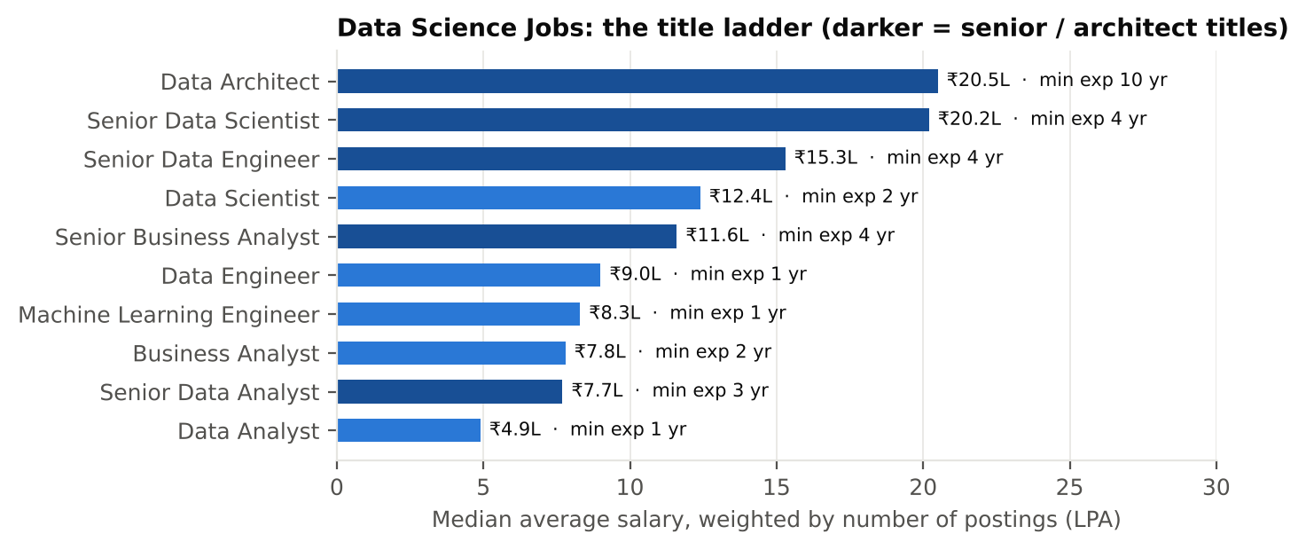
Figure 5. Median average salary by title, weighted by number of postings, with median minimum experience.
For our student user, this file also identifies fresher-friendly employers: companies posting many roles with minimum experience of 0–1 years. The largest include Accenture, Genpact and Cognizant (Business Analyst), and TCS, Cognizant and Accenture (Data Analyst); the full list (Table 26, Appendix G) feeds the Skill Investment Card.

3.6 What employers list
After normalising synonyms (e.g. "ms sql", "mysql", "sql server" → "sql"; "advanced excel" → "excel"), 64 skills appear in at least 50 data-role postings — our minimum support for estimating a premium. SQL (21%), Python, SAS, R, data analysis and machine learning (each about 18%) lead the list (Figure 6). This is the "Listed" axis: what a student sees in job ads.
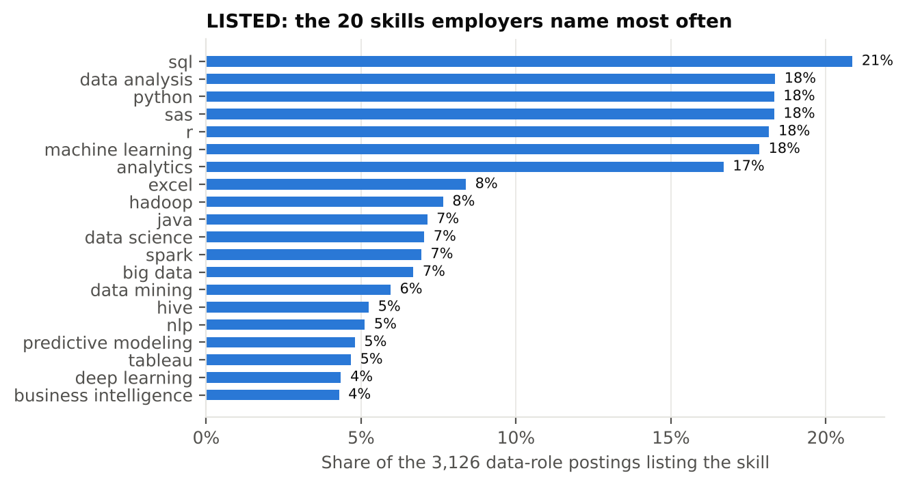
Figure 6. LISTED: the 20 skills named most often in data-role postings.
Skills are also listed in bundles (Table 27, Appendix G). Machine learning appears with Python in 313 postings — three times what independent listing would predict (lift 3.1) — and Hadoop appears with Hive and Spark 8–9 times more often than chance. For a student this means skills are bought together: the market rarely asks for machine learning without Python, or for Hadoop without its ecosystem.

3.7 Linking posting skills to the five junior skill areas
The junior file measures five broad areas, while postings list specific tools. We linked them with a keyword crosswalk. Because this is a judgement call, we built three versions: v1 (default) follows the JDS dictionary definitions (e.g. dashboard & storytelling includes "visualisation, reporting and storytelling", so Excel, MIS and reporting count); strict keeps only core tools (dashboard = Tableau, Power BI, Qlik, Spotfire, dashboard, visualisation, storytelling); broad adds neighbouring terms. A hand check of 30 matched postings per area under v1 confirmed the keywords match what they should. Table 9 shows how often each area is listed under each version.
Table 9. Share of data-role postings listing each area, by crosswalk version.
Skill area | v1 (default) | Strict | Broad
Coding | 57% | 54% | 59%
Big data | 20% | 16% | 22%
Maths & stats | 16% | 14% | 17%
AI / ML | 25% | 21% | 30%
Dashboard & storytelling | 21% | 9% | 25%

Dashboards & storytelling is the most sensitive area: it drops from 21% to 9% of postings when Excel, MIS and reporting are excluded. Section 4.3 shows this matters.

3.8 Junior and senior files
Both files load cleanly: all JDS scores lie within 1–5 at one decimal; all SDS scores are integers between 17 and 68; both outcomes are balanced (52.5% and 52.8% "high"). The largest correlation between predictors is 0.45 in each file, so collinearity is not a concern (all variance inflation factors < 1.5). Two features need care. JDS shows a strong ceiling effect: between 18% (big data) and 58% (dashboard & storytelling) of juniors score exactly 5.0, which compresses differences at the top. And in both files some IDs are reused by different people; keeping all rows changes the cross-validated AUC by less than 0.012.
Figure 7 shows the junior distributions by outcome. In every area except big data, the "5" column is dominated by high-hike juniors — 84% of high-hike juniors score 5 in dashboard & storytelling against 30% of low-hike juniors — so the ceiling is itself informative, but it limits how finely the top can be ranked. Figure 8 shows the senior traits: high-success seniors score markedly higher on extraversion, openness and conscientiousness, while neuroticism barely differs.
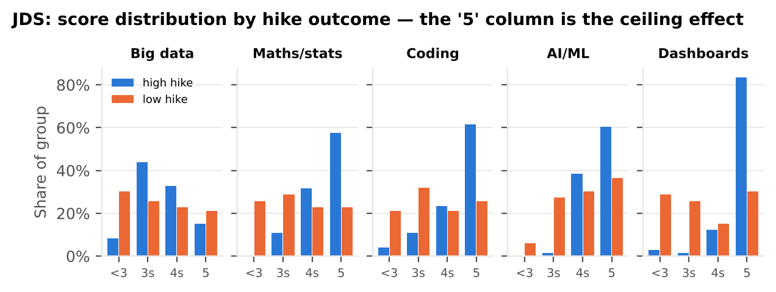
Figure 7. JDS: share of high-hike and low-hike juniors in each score range, by skill area.
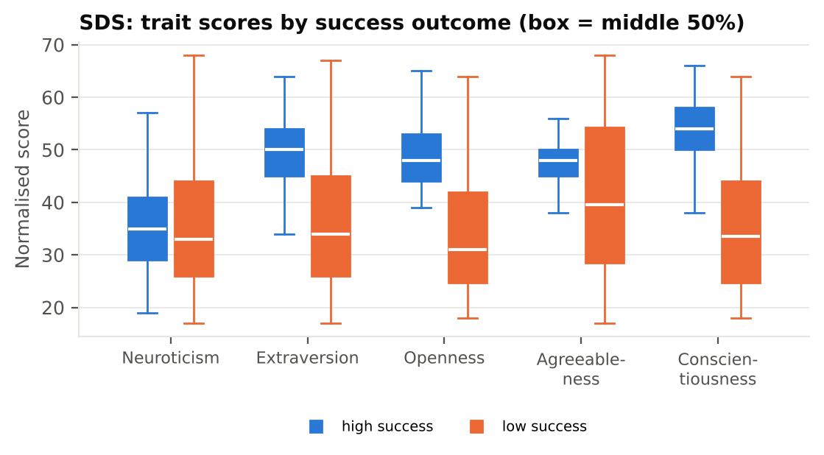
Figure 8. SDS: trait scores of high- and low-success seniors.

4. Data analysis

4.1 Market price: what the market pays

4.1.1 Model
For the 3,126 Indian data-role postings, we model the salary band (six ordered levels) with a proportional-odds logistic regression. Each of the five skill-area flags enters together, so each premium is net of the others. Controls are added in three stages: M0 raw; M1 + minimum experience (with a squared term) and city; M2 + role family. An odds ratio (OR) above 1 means postings listing the skill are more likely to sit in a higher salary band.

4.1.2 The premium waterfall
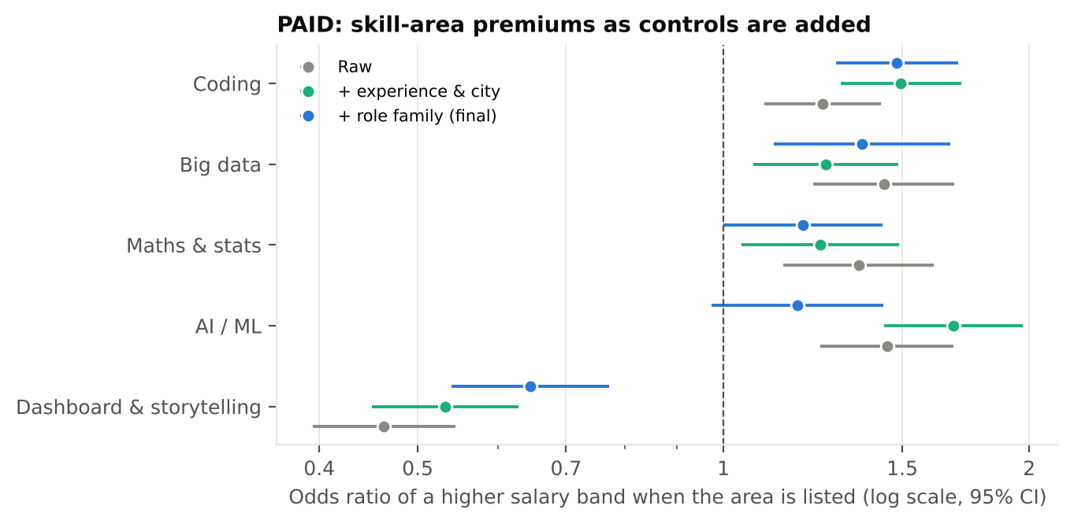
Figure 9. PAID: skill-area premiums as controls are added (95% confidence intervals).
Table 10. Market premiums by skill area. The last column comes from a separate interval regression on log-salary.
Skill area | M0 raw OR | M1 OR | M2 OR [95% CI] | p (M2) | Interval regression: salary premium
Coding | 1.25 | 1.49 | 1.48 [1.29, 1.70] | 0.000 | +12.5% [+8.1, +17.0]
Big data | 1.44 | 1.26 | 1.37 [1.12, 1.67] | 0.002 | +11.0% [+4.7, +17.7]
Maths & stats | 1.36 | 1.25 | 1.20 [1.00, 1.43] | 0.051 | +5.0% [-0.3, +10.7]
AI / ML | 1.45 | 1.68 | 1.18 [0.97, 1.44] | 0.091 | +5.3% [-0.4, +11.4]
Dashboard & storytelling | 0.46 | 0.53 | 0.65 [0.54, 0.77] | 0.000 | -11.6% [-16.0, -6.9]

Three patterns stand out. Coding and big data carry robust premiums of about +12.5% and +11% in salary within the same role family. AI/ML has the largest premium after experience and city (OR 1.68) but most of it disappears once role family is added (1.18, interval crossing 1): AI/ML pays because ML jobs are better-paid jobs, not because the skill adds pay within a comparable job. Dashboards & storytelling looks penalised (OR 0.65, about −11.6% salary) — Section 4.3 shows this is driven by how the area is defined.

4.1.3 Individual skills
Fitting M2 to each of the 64 skills with at least 50 postings and controlling the false-discovery rate leaves 13 skills with a reliable premium or penalty (Figure 10; full table in Appendix D). The strongest premiums are for statistical depth — statistical analysis (OR 2.42), logistic regression (2.11), model development (2.01) — and for algorithms and programming (algorithms 2.20, C++ 1.89, Java 1.60, R 1.47, SAS 1.37, Python 1.36). Tableau carries a premium (1.77), while Excel (0.60) and MIS (0.15) carry penalties. Several heavily listed skills — SQL, machine learning, Hadoop, big data, deep learning — do not survive the correction, which supports H1: being listed often and being paid more are different things.
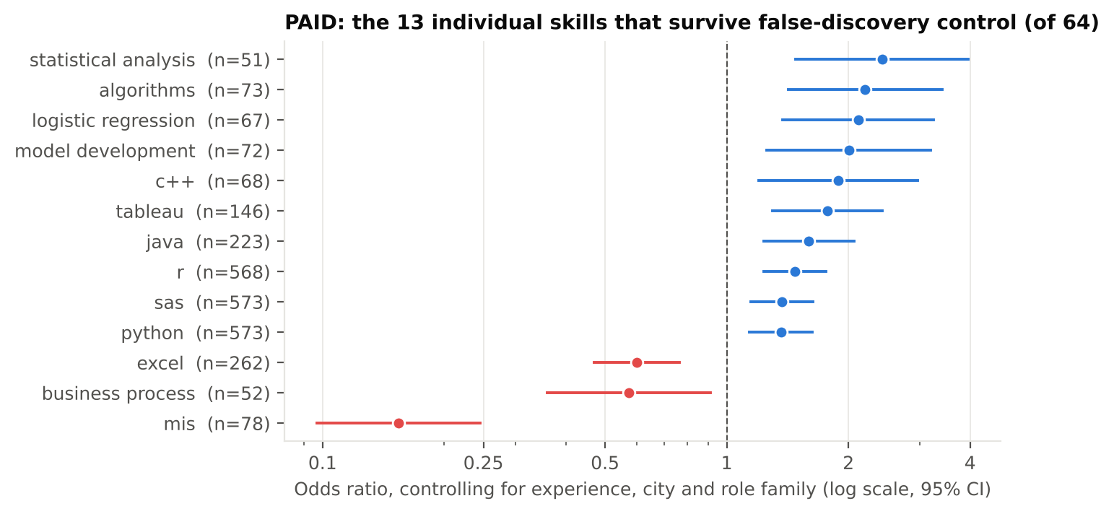
Figure 10. PAID: individual skills whose premium or penalty survives Benjamini–Hochberg control (q < 0.10), with n postings.

4.1.4 Career stage
Fitting M2 separately to postings needing 0–3 years (n = 1,337) and 5+ years (n = 1,412) shows that what pays depends on career stage (Figure 11, Table 11), supporting H2. At entry level, coding (1.89), big data (1.71) and maths & statistics (1.43) all carry premiums, while AI/ML carries none (0.99). At 5+ years the picture flattens: only coding keeps a clear premium.
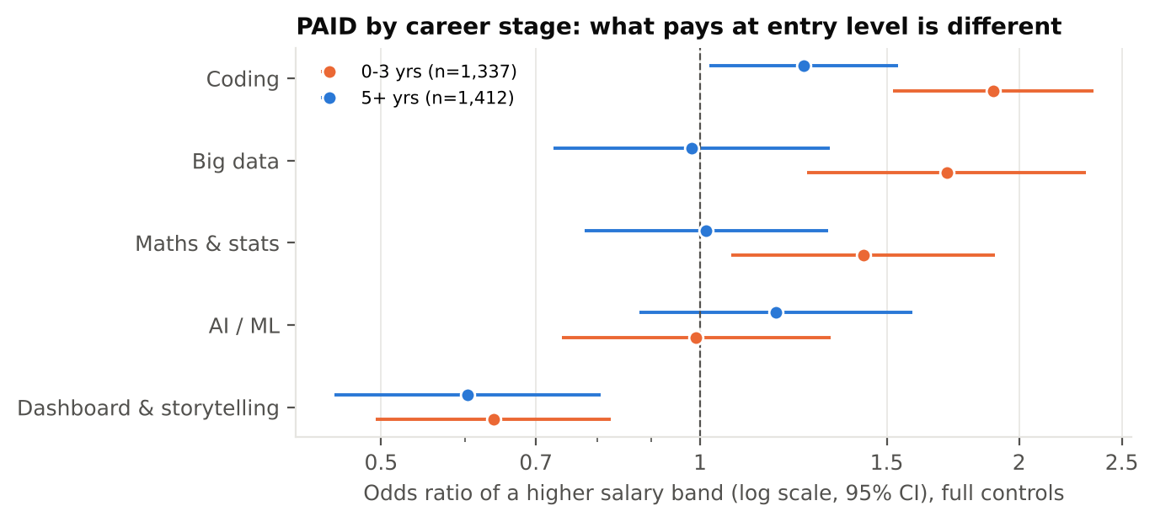
Figure 11. PAID by career stage: entry-level (0–3 years) vs experienced (5+ years) postings.
Table 11. Market premiums by career stage, full controls.
Skill area | 0–3 years: OR [95% CI] | 5+ years: OR [95% CI]
Coding | 1.89 [1.52, 2.35] | 1.25 [1.02, 1.54]
Big data | 1.71 [1.26, 2.31] | 0.98 [0.73, 1.32]
Maths & stats | 1.43 [1.07, 1.90] | 1.01 [0.78, 1.32]
AI / ML | 0.99 [0.74, 1.33] | 1.18 [0.88, 1.59]
Dashboard & storytelling | 0.64 [0.49, 0.82] | 0.60 [0.45, 0.81]

The AI/ML result at entry level holds under all three crosswalks (OR 0.99, 1.10 and 1.19 for v1, strict and broad; none clearly above 1). This is the headline message for students: AI/ML skills open the door to better-paid role families, but at entry level they do not earn a premium over peers in the same kind of role.
Table 12. Entry-level (0–3 years) market odds ratios under each crosswalk version.
Skill area | v1 (default) | Strict | Broad
Coding | 1.89 | 1.68 | 1.81
Big data | 1.71 | 1.60 | 1.51
Maths & stats | 1.43 | 1.64 | 1.29
AI / ML | 0.99 | 1.10 | 1.19
Dashboard & storytelling | 0.64 | 1.61 | 0.73

Table 12 also shows the one area that changes sign with the crosswalk at entry level: dashboards & storytelling, whose odds ratio is 0.64 when Excel and MIS reporting are included and 1.61 when only core visualisation tools are counted.

4.1.5 Robustness of the market results
Table 13. Robustness checks on the market model.
Check | What was done | Result
Proportional-odds assumption | Separate binary logits at each of the 5 cut points | Directions hold at every cut for coding, big data and dashboards. Coding's effect is largest at the bottom (OR 3.13 for leaving the 0–3 LPA band) and smaller at the top (1.14): coding mainly lifts juniors out of the lowest bands
Alternative model | Interval regression on log-salary with band edges | Same sign for all five areas
Complete skill lists only (n = 500) | Re-fit M2 on postings without "..." truncation | Same sign for all five; intervals wider (e.g. coding 1.34 [0.94, 1.91]; dashboard 0.51 [0.31, 0.83])
Null test | Shuffle the AI/ML flag 200 times | Shuffled ORs centre on 0.995 (95% range 0.87–1.17): the model does not invent premiums
Cleaning choices | Undo de-duplication, non-India exclusion, city normalisation, filter | Area ORs move by at most 0.15 (coding without de-duplication); no sign changes (Table 6)

Separate models for each cut point (Table 28, Appendix G) show where in the pay scale each skill matters. Coding and maths & statistics mainly lift postings out of the bottom bands; AI/ML matters at the very bottom and the very top but not in the middle — consistent with AI/ML being a marker of specialist, senior roles rather than a general premium.

4.2 Internal reward: what one company rewards
For the 139 juniors, a logistic regression on the five standardised skill scores predicts a high salary hike with a cross-validated AUC of 0.90 ± 0.05 (5 folds × 20 repeats). A permutation test confirms the signal is real: across 500 label shuffles the 95th-percentile AUC is 0.61, and the observed value gives p = 0.002. Predictions are well calibrated (Brier score 0.118), and a depth-3 decision tree reaches 0.82, a little lower, with readable rules: juniors scoring above 4.15 in dashboard & storytelling, above 3.55 in maths & stats and above 4.65 in coding had a high hike in 51 of 57 cases.
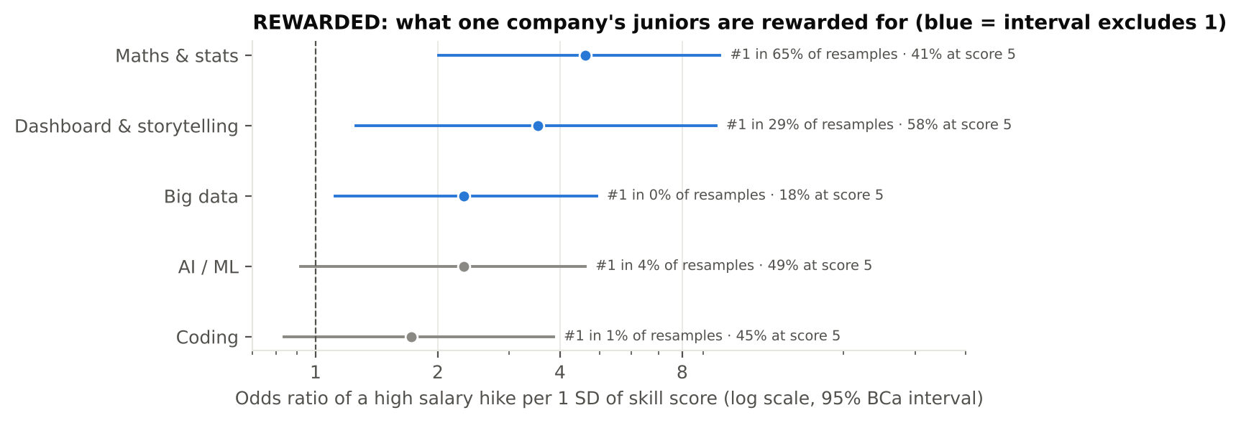
Figure 12. REWARDED: odds ratio of a high hike per standard deviation of each skill score, with 95% BCa intervals, the share of 2,000 resamples in which the skill ranks first, and the ceiling share.
Table 14. Internal reward for each junior skill area (multivariable model).
Skill area | Mean score high / low hike | OR per SD [95% BCa] | Ranked 1st | Sign stable | Single-skill AUC [95% BCa] | At score 5
Maths & stats | 4.71 / 3.83 | 4.62 [2.01, 9.90] | 65% | 100.0% | 0.78 [0.69, 0.84] | 41%
Dashboard & storytelling | 4.85 / 3.81 | 3.52 [1.26, 9.68] | 29% | 100.0% | 0.79 [0.72, 0.86] | 58%
Big data | 3.94 / 3.75 | 2.32 [1.12, 4.92] | 0% | 99.7% | 0.56 [0.47, 0.66] | 18%
AI / ML | 4.82 / 4.28 | 2.32 [0.92, 4.61] | 4% | 99.3% | 0.68 [0.59, 0.76] | 49%
Coding | 4.64 / 3.85 | 1.72 [0.84, 3.86] | 1% | 93.3% | 0.74 [0.67, 0.81] | 45%

Maths & statistics is the most consistently rewarded skill (OR 4.6 per SD; ranked first in 65% of resamples), followed by dashboard & storytelling (3.5; first in 29%). Big data is also clearly rewarded once the others are held constant, even though on its own it barely separates high from low (AUC 0.56). Coding and AI/ML point the same way, but their intervals include 1, partly because 45–49% of juniors are already at the maximum score in those areas. Adding "at ceiling" indicators keeps maths & stats first but swaps the order below it, so we treat only the first place as firm.
Calibration (Table 29, Appendix G) is good in the upper three quintiles; at the bottom the model is slightly over-confident, so a "very unlikely" prediction should be read as "unlikely".

4.2.1 Generalist or specialist?
A common student dilemma is whether to be good at everything or excellent at one thing. The weakest of a junior's five scores predicts a high hike far better than the strongest (Figure 13): AUC 0.85 vs 0.59, a paired-bootstrap difference of 0.26 [0.18, 0.35]. But the average of the five predicts best of all (0.92), and once the average is in the model, the spread of scores adds nothing (OR 0.76 per SD of spread, [0.38, 1.54]). The honest reading is "don't leave an area weak", not "be a generalist": rewards track the overall level, and a single weak area drags it down.
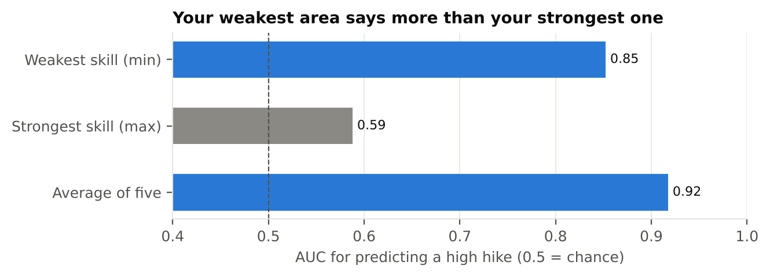
Figure 13. How well three summaries of a junior's five scores predict a high hike.

4.3 The bridge: Listed vs Paid vs Rewarded
Table 15 places the three measurements side by side for each area, with the market premium shown under all three crosswalks (Figure 14). An area is "paid" when its 95% interval lies above 1, and "rewarded" when its BCa interval lies above 1. We call a disagreement real only if it appears under at least two of the three crosswalks.
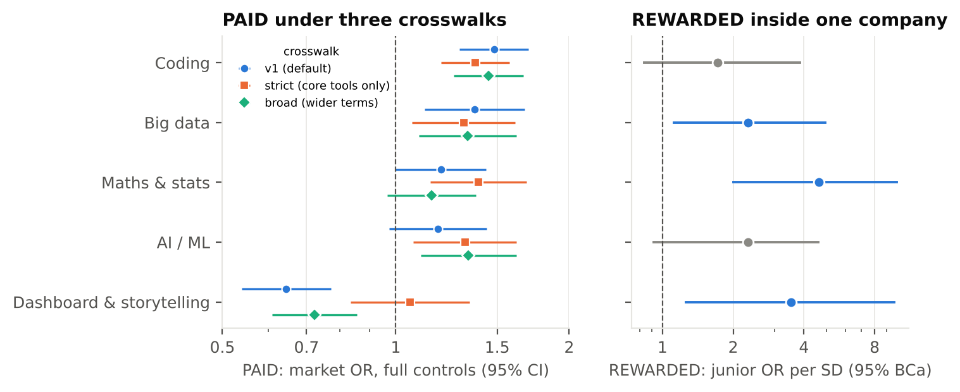
Figure 14. Left: market premium under three crosswalk versions. Right: internal reward for juniors (blue = interval excludes 1).
Table 15. Listed vs Paid vs Rewarded, with 95% intervals.
Skill area | Listed | Paid: v1 | Paid: strict | Paid: broad | Rewarded (OR/SD)
Coding | 57% | 1.48 [1.29, 1.70] | 1.37 [1.20, 1.58] | 1.45 [1.26, 1.66] | 1.7 [0.8, 3.9]
Big data | 20% | 1.37 [1.12, 1.67] | 1.31 [1.07, 1.61] | 1.33 [1.10, 1.62] | 2.3 [1.1, 4.9]
Maths & stats | 16% | 1.20 [1.00, 1.43] | 1.39 [1.15, 1.69] | 1.15 [0.97, 1.38] | 4.6 [2.0, 9.9]
AI / ML | 25% | 1.18 [0.97, 1.44] | 1.32 [1.07, 1.62] | 1.34 [1.10, 1.62] | 2.3 [0.9, 4.6]
Dashboard & storytelling | 21% | 0.65 [0.54, 0.77] | 1.06 [0.84, 1.34] | 0.72 [0.61, 0.86] | 3.5 [1.3, 9.7]

Table 16. Verdict per skill area. Supports H3.
Skill area | Market | Company | Verdict (robust across crosswalks)
Big data | Paid in 3/3 | Rewarded | Agree — paid and rewarded
Coding | Paid in 3/3 | Not clearly | Paid more than rewarded — the company's juniors are mostly at the ceiling
Maths & stats | Paid in 1/3 | Rewarded (strongest) | Rewarded more than paid
AI / ML | Paid in 2/3 (overall); not at entry level in any | Not clearly | Weakest case for a junior to prioritise
Dashboard & storytelling | Penalised in 2/3; neutral under strict | Rewarded | Rewarded, not paid — the market penalty is not robust

The rank correlation between Paid and Rewarded across the five areas is −0.5 (v1), 0.0 (strict) and −0.9 (broad), with bootstrap intervals spanning roughly −1 to +0.3. With only five areas we make no significance claim on the correlation itself; the evidence is the per-area verdicts above. Together they say that what the market pays and what an employer rewards do not line up, and the two biggest gaps are maths & statistics and dashboards & storytelling — both undervalued by the market relative to their internal reward.
Why the crosswalk check mattered. Under the default mapping, dashboards & storytelling looked like a market penalty (OR 0.65). With core visualisation tools only, the penalty vanishes (1.06) and at entry level becomes a premium (1.61). The "penalty" came from Excel and MIS reporting jobs, not from Tableau or Power BI. Without this check we would have told students the opposite of the truth.

4.4 Senior profile: career-stage contrast and a label check
For the 161 seniors, a linear logistic model on the five standardised traits gives a cross-validated AUC of 0.963 (permutation p = 0.002). Openness to experience and conscientiousness have by far the largest effects (Table 17).
Table 17. Senior success: linear logistic model on standardised traits.
Trait | Mean high / low success | OR per SD [95% CI] | p | Single-trait AUC
Neuroticism | 36.1 / 36.3 | 3.9 [1.7, 9.0] | 0.001 | 0.53
Extraversion | 48.9 / 36.9 | 3.9 [1.5, 10.2] | 0.005 | 0.78
Openness to experience | 48.5 / 33.3 | 20.8 [5.8, 74.8] | 0.000 | 0.88
Agreeableness | 47.7 / 41.1 | 2.5 [1.0, 6.2] | 0.056 | 0.65
Conscientiousness | 53.7 / 35.7 | 26.5 [5.8, 120.9] | 0.000 | 0.88

4.4.1 Curved effects (H4)
Adding squared terms makes the unpenalised model separate the classes perfectly (training accuracy 100%, p-values ≈ 1), so the textbook likelihood-ratio test is invalid here. With a ridge penalty, curvature still lifts cross-validated AUC from 0.967 to 0.998, and the squared terms are negative for extraversion, openness and agreeableness: higher is better, with diminishing returns at the top. H4 is supported, with the caveat below.

4.4.2 Is the label reproducible from the scores?
Several signs point to a success label constructed from the trait scores themselves. A single cut-off on the plain total of all five scores classifies 92.5% of seniors correctly (90.9% when the cut-off is chosen inside cross-validation), and the total alone matches the full model's AUC (0.961 vs 0.963). Neuroticism, described as a negative trait, has no relationship with success on its own (AUC 0.53) yet a positive weight inside the model (OR 3.9) — exactly what happens if the label was built from an unweighted total. Finally, success rises in near-steps with the number of traits above the median (Figure 15): from 6% with none to 97% with four and 100% with five.
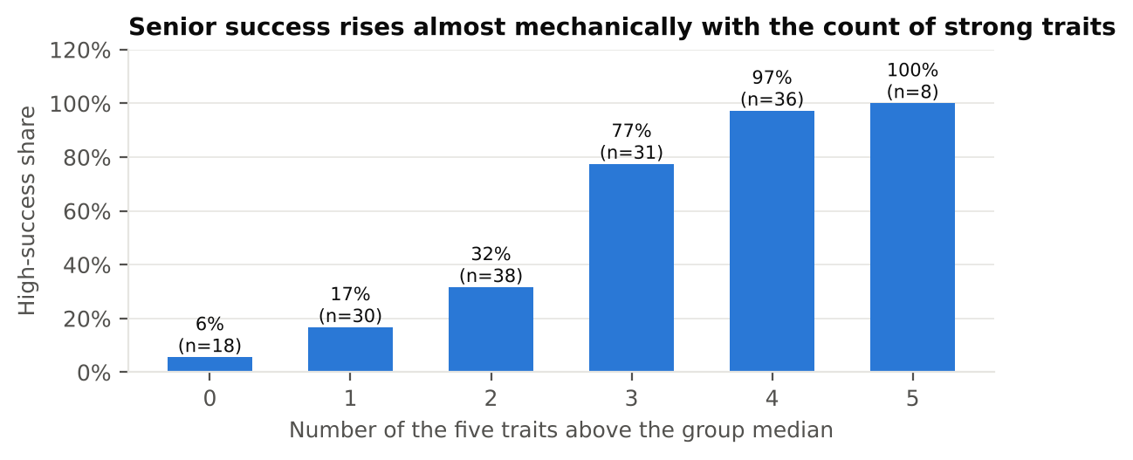
Figure 15. Senior high-success share by number of traits above the group median.
We therefore report the senior model as a finding about the data: the label behaves like a near-mechanical function of the scores, so a 0.96–0.998 AUC says more about how the label was built than about real-world success. We use the file only for the career-stage contrast — juniors are rewarded for technical skills, seniors' success tracks how they think and work (openness, conscientiousness) — and never as a personality screen.
Table 18. Cross-validated performance of all people models (5 folds × 20 repeats).
File | Model | CV AUC (mean ± SD) | Note
JDS | Logistic, 5 skills | 0.905 ± 0.052 | Permutation p = 0.002; null 95th percentile 0.61
JDS | Decision tree, depth 3 | 0.818 ± 0.066 | Readable rules; lower accuracy
JDS | Average of five scores only | 0.917 (AUC) | The overall level carries most of the signal
SDS | Logistic, linear | 0.963 | Permutation p = 0.002
SDS | Ridge logistic, linear | 0.967 ± 0.026
SDS | Ridge logistic, with squared terms | 0.998 ± 0.003 | Unpenalised version separates perfectly
SDS | Total of five scores only | 0.961 | Single cut-off: 92.5% accurate (90.9% in CV)
SDS | Decision tree, depth 4 | 0.946

4.5 The Skill Investment Card

4.5.1 Algorithm
Input: the student's self-rating (1–5) in each area, target role family and experience band. For each area: the gap is the distance from the student's rating to the typical high-hike junior (median: 5.0 in four areas, 3.8 in big data). The value of closing that gap combines (a) the internal reward per rating point from 2,000 bootstrap fits of the junior model and (b) the market premium for that area at the student's career stage, drawn from all three crosswalks so the mapping uncertainty enters the interval. The two halves are scaled to a common range and weighted equally. Output: areas ranked by median value with 80% intervals and the share of draws in which each area is the best option.
Decision rules. Recommend when one area is best in at least 60% of draws; Tie when it is not; No gap when the student is within 0.3 points of the high-hike profile everywhere; Abstain when any rating is below the lowest observed score (2.2) or the profile is unlike any junior in the data (Mahalanobis distance above the 99th percentile).

4.5.2 Verification
Table 19. Tests of the Skill Investment Card.
Test | Expected | Result
Profile equal to the high-hike median | No gap | Pass
Weak only in maths & stats | Maths & stats ranked first | Pass
Weak only in coding | Coding ranked first | Pass
A rating below the observed range (2.0) | Abstain | Pass
Unusual profile (5, 2.3, 5, 2.3, 5) | Abstain | Pass
Monotonicity: lowering a rating never makes that area less recommended | 0 violations | 0 violations in 1,000 random profiles
Behaviour on the 66 low-hike juniors | Mostly decisive, some ties | 46 recommend, 17 tie, 2 abstain, 1 no gap

4.5.3 Example cards
Figure 16 shows two student profiles. Asha (final year, strong coder, weak in statistics and storytelling, aiming for a Data Analyst role) is advised to invest in maths & statistics, best in 89% of draws. Dashboards & storytelling is second with a wide interval, reflecting the crosswalk uncertainty in the market. Rohan (ML enthusiast, weak communication, aiming for Data Scientist roles) is also pointed to maths & statistics (61%) rather than more AI/ML, consistent with the absent entry-level AI/ML premium. Meera, within 0.3 points of the high-hike profile everywhere, gets "no gap". Kabir, whose coding self-rating (1.5) is below anything in the data, gets "not enough evidence" rather than a guess.
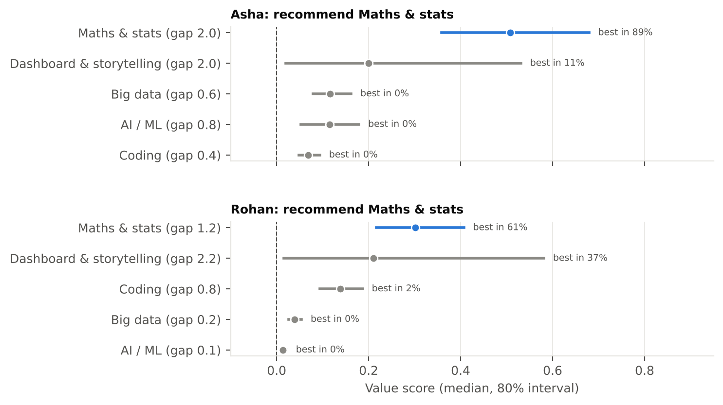
Figure 16. Skill Investment Card output for two personas: median value score, 80% interval, and share of draws in which each area is the best option.
Table 20. Skill Investment Card decisions for four student personas.
Persona | Self-ratings (big data, maths, coding, AI/ML, dashboards) | Target | Card decision
Asha | 3.2, 3.0, 4.6, 4.2, 3.0 | Data Analyst, 0–3 yrs | Recommend maths & stats (best in 89%); dashboards second
Rohan | 3.6, 3.8, 4.2, 4.9, 2.8 | Data Scientist / ML, 0–3 yrs | Recommend maths & stats (61%); dashboards close second (37%)
Meera | 4.6, 4.9, 4.9, 4.9, 4.8 | Data Analyst, 0–3 yrs | No gap: within 0.3 of the high-hike profile everywhere
Kabir | 3.5, 3.5, 1.5, 3.5, 3.5 | Data Engineer, 0–3 yrs | Abstain: coding rating below anything in the data

5. Results and conclusions

5.1 Answer to the core question
Table 21. The core question, answered.
Part of the question | Answer | How sure
What does the market pay for? | Coding (+12.5%) and big data (+11%) within role family; statistical depth (statistical analysis, logistic regression, model development) and programming at skill level. At entry level: coding, big data, maths & stats | High: survives 3 crosswalks, interval regression, complete-list subset, FDR control
What does one company reward? | Maths & statistics most, then dashboards & storytelling and big data; overall level matters more than any one spike | Moderate: n = 139, one company; BCa intervals wide but first place stable (65%)
Where do they disagree? | Maths & stats and dashboards & storytelling are rewarded more than paid; coding is paid more than rewarded; AI/ML is neither paid at entry level nor clearly rewarded | Disagreements counted only if they hold in ≥ 2 of 3 crosswalks
How sure are we? | Every estimate carries an interval; the card abstains or reports ties when evidence is thin | 17 of 66 low-hike juniors receive "tie", not a forced answer

5.2 Hypotheses
Table 22. Hypothesis outcomes.
Hypothesis | Outcome | Evidence
H1: most listed ≠ most paid | Supported | SQL, machine learning, Hadoop and big data are among the most listed but not significant after FDR control; less-listed statistical skills carry the largest premiums
H2: entry vs experienced differ | Supported | Big data and maths & stats pay at 0–3 years, not at 5+; AI/ML pays at neither stage clearly, and not at all at entry level
H3: robust Paid–Rewarded disagreement | Supported | Four of five areas disagree in ≥ 2 of 3 crosswalks
H4: curved senior effects | Supported, with caveat | Penalised CV AUC 0.967 → 0.998 with negative squared terms; but the label is near-mechanical

5.3 Conclusions
- Demand is not value. The most listed skills are not the best paid within comparable jobs. Students reading skill lists are seeing demand, not price.
- For a fresher, AI/ML is a door, not a raise. It moves you into better-paid role families, but within those families entry-level AI/ML adds no measurable premium. Coding, data engineering and statistics do.
- Foundations are undervalued by the market but rewarded after hiring. Maths & statistics is the strongest internal reward driver yet only modestly priced in postings — the clearest case where a student's investment pays after hiring more than the job ad suggests.
- "Dashboards" means two different things. Real visualisation tools pay; Excel and MIS reporting jobs do not. Storytelling is rewarded internally either way.
- Close weak areas before deepening strong ones. Internal rewards follow the overall level of skills, so one weak area costs more than one extra-strong area earns.
- Check labels before trusting models. The senior label is reproducible from its inputs; the high AUC is a property of the data, not evidence of a predictive tool.

6. Implications

6.1 For students and early-career analysts
- Use the Skill Investment Card, not the skill-list headline. It shows the gap, the value of closing it, and how sure the estimate is.
- Do not skip statistics for a shortcut into AI/ML. Statistical depth (regression, model development, statistical analysis) carries the largest skill premiums and the strongest internal reward.
- Learn a real visualisation tool, not just Excel. Tableau/Power BI-type skills pay at entry level; Excel/MIS reporting roles sit in lower bands.
- Coding is the safest single investment for a fresher — the largest and most robust entry-level premium (OR 1.89).
- Fix the weakest area first. A balanced profile without a weak spot is what the employer in our data rewarded.
- Target fresher-friendly employers deliberately. The ten largest posters account for 35% of postings; several hire at 0–1 years in large numbers.
Table 23. Student action guide derived from the findings.
If you are… | Prioritise | Because
Strong in coding, weak in statistics | Maths & statistics | Strongest internal reward; premium at entry level (1.43)
Aiming for ML roles straight away | Statistics and coding before more AI/ML | No entry-level AI/ML premium within role family
Comfortable with Excel reporting | A real BI tool (Tableau / Power BI) plus storytelling | Core tools pay at entry level (1.61); Excel/MIS do not (0.60 / 0.15)
Interested in data engineering | Big data with its ecosystem (Hadoop + Spark + Hive) | Premium at entry level (1.71); skills listed as bundles
Balanced but nowhere near the top | Your weakest area first | Rewards follow the overall level; a weak area drags it down

6.2 For universities
- Keep, and make visible, a strong statistics and modelling core; the evidence suggests it is undervalued by students reading job ads.
- Teach visualisation with industry tools and pair it with storytelling practice, rather than spreadsheet reporting alone.
- Publish skill guidance with uncertainty and career stage; "AI/ML is in demand" is true but incomplete advice for a fresher.

6.3 For employers and recruiters
- Job descriptions that list AI/ML for entry-level roles without paying for it attract mismatched expectations; listing statistics and storytelling where they are rewarded internally would signal more accurately.
- Internal reward systems that track overall skill level (as here) favour balanced profiles; communicating that to juniors would focus their development.
- Labels used for "success" should be checked for construction from their own inputs before being used in any analysis.

6.4 Limitations
- Association, not causation. Premiums are what postings with a skill offer in comparable jobs, not the raise a person would get from learning it.
- Truncated skill lists (87%) mean skill flags capture only the first-named skills; the complete-list subset agrees in direction but is small (n = 500).
- One company each for the junior and senior files; their findings are a case study, not industry-wide.
- Self-ratings vs measured scores. The card asks students to rate themselves on a scale the company measured by tests; ratings may be optimistic.
- Single-reviewer labelling. The data-role and role-family gold samples were labelled by one reviewer; an independent second labelling and agreement statistic would strengthen the filter validation.
- Crosswalk judgement. Three versions reduce, but do not remove, the subjectivity of mapping tools to areas.

6.5 Next steps
With more time and data access: validate the card prospectively (ask students to rate themselves and follow their outcomes), add complete skill lists from job descriptions, repeat the junior analysis across several employers, and extend the market model to time trends using posting dates.

6.6 References
[1] Naukri. Naukri JobSpeak: White-collar hiring remains stable in May; AI/ML roles and Insurance sector continue to lead. 1 June 2026. https://www.naukri.com/blog/naukri-jobspeak-may-2026-white-collar-hiring-remains-stable-in-may-ai-ml-roles-and-insurance-sector-continue-to-lead/
[2] SAS Institute. SAS CU Hackathon: Problem Context Brief, Data Description Document. 2026.

Appendix

A. Audit log (row-level)
Table 24. Row-level audit log produced by the pipeline.
Step | Rows in | Rows out | Note
DS.surrogate_key | 1,602 | 1,602 | 276 rows share a reference_no with another company; row key added
DS.flags | 1,602 | 1,602 | Flagged 3 with min experience ≥ 15 and 12 with average salary < 2 LPA (kept)
AJ.dedup | 15,841 | 14,840 | Exact duplicates ignoring s_no removed
AJ.skills | 14,840 | 14,840 | 87% of skill lists end in "..." (truncated); trailing dots stripped
AJ.data_role_v3 | 14,840 | 3,149 | Validated title-or-skills filter (precision 0.92, recall 0.81 on an untouched sample)
AJ.non_india | 3,149 | 3,126 | Non-India data postings excluded
JDS.ids | 139 | 139 | 4 rows share an id with different values; kept, row key added
SDS.columns | 161 | 161 | Stray spaces stripped from column names
SDS.ids | 161 | 161 | 18 rows share an id with different values; kept, row key added

B. Known-answer and null tests
All tests use seed 2026. Ordinal model: latent log-salary = log 4 + 0.12 × experience + 0.25 × skill + logistic noise (scale 0.35), banded at 3, 6, 10, 15 and 25 LPA; 200 replications of n = 2,700. Bootstrap: real JDS predictors, standardised, with planted coefficients (0, 0.8, 0.6, 0.3, 0.9); 60 replications × 400 resamples. Permutation: 200 null datasets of n = 150; one dataset with a logistic effect of 1.0. BH: 40 uniform and 10 near-zero p-values, 300 replications. Curvature LRT: n = 161, five standard-normal traits, quadratic term 0 or −0.8 on one trait; 200 replications each. Market null test: the AI/ML flag shuffled 200 times within the real data.

C. Data-role labelling protocol
Label "data role" if the core work of the job is analysing data, building statistical or machine-learning models, data engineering (ETL, data warehousing, big-data platforms) or BI/reporting development. Label "not a data role" for software development, testing, finance, marketing/SEO, sales, operations, administration of infrastructure (including database and Hadoop administrators) and data entry. Titles such as "Business Analyst" count only when the listed skills show analytical work (statistics, SQL, BI tools) rather than requirements gathering. Three rounds of 200 random postings were labelled without seeing the filter's decision; round 3 was drawn only after the filter was frozen. Role families were checked on a further 100 kept postings (95 data roles; 86 assigned to the same family as the reviewer, 90.5%).

D. Market premium for every skill with ≥ 50 postings
Table 25. All 64 skills, sorted by M2 odds ratio.
Skill | n | Raw OR | M2 OR [95% CI] | q (BH) | Survives
statistical analysis | 51 | 1.65 | 2.42 [1.48, 3.96] | 0.004 | yes
algorithms | 73 | 2.19 | 2.20 [1.42, 3.41] | 0.004 | yes
logistic regression | 67 | 2.28 | 2.11 [1.37, 3.25] | 0.005 | yes
model development | 72 | 3.08 | 2.01 [1.26, 3.20] | 0.020 | yes
c++ | 68 | 2.16 | 1.89 [1.20, 2.96] | 0.031 | yes
tableau | 146 | 1.13 | 1.77 [1.30, 2.42] | 0.004 | yes
java | 223 | 1.78 | 1.60 [1.23, 2.06] | 0.004 | yes
c | 50 | 2.25 | 1.58 [0.94, 2.65] | 0.250
r | 568 | 1.92 | 1.47 [1.24, 1.76] | 0.000 | yes
statistical modeling | 114 | 2.01 | 1.47 [1.04, 2.07] | 0.106
advanced analytics | 52 | 1.76 | 1.43 [0.86, 2.36] | 0.344
nlp | 160 | 1.73 | 1.40 [1.02, 1.92] | 0.135
sas sql | 69 | 1.27 | 1.38 [0.90, 2.12] | 0.312
data warehousing | 92 | 1.14 | 1.37 [0.93, 2.00] | 0.271
sas | 573 | 1.54 | 1.37 [1.15, 1.63] | 0.004 | yes
etl | 98 | 1.12 | 1.36 [0.94, 1.99] | 0.271
python | 573 | 1.32 | 1.36 [1.14, 1.63] | 0.005 | yes
business analysis | 107 | 0.72 | 1.33 [0.94, 1.89] | 0.271
project management | 92 | 1.68 | 1.31 [0.90, 1.93] | 0.340
segmentation | 56 | 2.28 | 1.31 [0.80, 2.14] | 0.473
business intelligence | 134 | 0.73 | 1.30 [0.95, 1.79] | 0.271
spark | 217 | 1.60 | 1.28 [0.97, 1.69] | 0.247
nosql | 99 | 1.38 | 1.27 [0.87, 1.84] | 0.396
machine learning | 558 | 1.72 | 1.26 [1.03, 1.54] | 0.106
data mining | 186 | 1.19 | 1.25 [0.95, 1.65] | 0.277
scala | 95 | 1.31 | 1.24 [0.84, 1.83] | 0.463
deep learning | 136 | 1.73 | 1.21 [0.86, 1.70] | 0.463
sql | 652 | 0.83 | 1.20 [1.02, 1.40] | 0.106
data visualization | 61 | 0.73 | 1.16 [0.73, 1.85] | 0.750
vba | 54 | 0.70 | 1.15 [0.71, 1.88] | 0.762
hbase | 68 | 1.16 | 1.12 [0.72, 1.74] | 0.794
mapreduce | 60 | 1.50 | 1.12 [0.69, 1.82] | 0.811
analytics | 522 | 1.12 | 1.11 [0.93, 1.32] | 0.459
marketing analytics | 63 | 1.16 | 1.11 [0.70, 1.74] | 0.819
data science | 220 | 1.62 | 1.10 [0.83, 1.45] | 0.736
hadoop | 239 | 1.39 | 1.08 [0.83, 1.41] | 0.762
statistics | 93 | 0.98 | 1.06 [0.72, 1.56] | 0.897
big data | 209 | 1.47 | 1.05 [0.80, 1.39] | 0.870
data modeling | 89 | 1.17 | 1.04 [0.70, 1.53] | 0.946
neural networks | 54 | 2.15 | 1.03 [0.62, 1.72] | 0.969
oracle | 54 | 0.97 | 1.03 [0.64, 1.65] | 0.969
business analytics | 60 | 0.75 | 1.02 [0.64, 1.61] | 0.979
linear regression | 60 | 1.75 | 1.01 [0.62, 1.65] | 0.979
banking | 50 | 1.75 | 1.01 [0.59, 1.73] | 0.979
hdfs | 53 | 1.23 | 0.98 [0.59, 1.64] | 0.979
text mining | 73 | 2.10 | 0.97 [0.63, 1.48] | 0.969
predictive modeling | 150 | 1.39 | 0.96 [0.70, 1.31] | 0.912
hive | 164 | 1.31 | 0.95 [0.70, 1.29] | 0.897
predictive analytics | 126 | 1.30 | 0.90 [0.64, 1.27] | 0.762
javascript | 67 | 0.73 | 0.90 [0.58, 1.40] | 0.808
data analysis | 574 | 0.62 | 0.82 [0.69, 0.98] | 0.106
spss | 58 | 0.49 | 0.82 [0.51, 1.30] | 0.590
finance | 57 | 1.19 | 0.80 [0.48, 1.30] | 0.555
data analyst | 51 | 0.40 | 0.79 [0.47, 1.32] | 0.555
pig | 61 | 1.00 | 0.78 [0.49, 1.25] | 0.486
data management | 89 | 0.45 | 0.76 [0.52, 1.11] | 0.338
consulting | 57 | 0.47 | 0.76 [0.47, 1.21] | 0.444
power bi | 72 | 0.48 | 0.75 [0.49, 1.15] | 0.380
ssis | 58 | 0.32 | 0.72 [0.44, 1.19] | 0.388
data scientist | 68 | 1.38 | 0.67 [0.43, 1.07] | 0.266
outsourcing | 63 | 0.24 | 0.62 [0.41, 0.95] | 0.106
excel | 262 | 0.36 | 0.60 [0.47, 0.76] | 0.001 | yes
business process | 52 | 0.27 | 0.57 [0.36, 0.91] | 0.092 | yes
mis | 78 | 0.07 | 0.15 [0.10, 0.25] | 0.000 | yes

E. SAS Viya for Learners implementation
- Upload sas_data_role_postings.csv, sas_ds_jobs.csv, sas_jds.csv and sas_sds.csv (exported by the pipeline) to SAS Viya for Learners and load them into CAS.
- SAS Visual Analytics report, page 1 (Market): salary band by experience heat map; title ladder; top listed skills with role-family and city filters.
- Page 2 (Bridge): Listed vs Paid vs Rewarded table and chart, with a crosswalk-version selector.
- Page 3 (Skill Investment Card): five slider parameters for self-ratings, a role-family selector and the ranked output with intervals.
- SAS Model Studio: one pipeline each for JDS (target salary_hike_high_or_low) and SDS (target success) with logistic regression, decision tree, forest and gradient boosting on 5-fold partitions; compare AUC with the Python results (agreement within ±0.03 expected).

NOTE: SAS VIYA REQUIRES BUSSINESS EMAIL SO WE COULD NOT VALIDATE IT WITH SAS VIYA:

F. Code and reproducibility
pipeline_v1.py (cleaning and assertions), verify_methods.py (known-answer tests), prep.py (analysis tables and SAS exports), market.py (Section 4.1), people.py (Sections 4.2 and 4.4), bridge_card.py and card.py (Sections 4.3 and 4.5), audit_effects.py (Table 6), figures.py (all figures, each saved with its data). Every run prints the SHA-256 hashes of the four raw files.

G. Supporting tables
Table 26. Largest fresher-friendly employers in Data Science Jobs (minimum experience 0–1 years).
Company | Title | Min. exp (yrs) | Avg salary (LPA) | Postings
Accenture | Business Analyst | 1 | 7.0 | 1,900
Genpact | Business Analyst | 1 | 6.4 | 1,700
TCS | Data Analyst | 1 | 4.7 | 1,600
Cognizant | Data Analyst | 1 | 5.5 | 1,200
Cognizant | Business Analyst | 1 | 8.6 | 1,100
Accenture | Data Analyst | 1 | 5.2 | 1,100
Deloitte | Business Analyst | 1 | 7.8 | 991
TCS | Data Engineer | 1 | 5.8 | 819

Table 27. Most frequent skill pairs among the top 30 skills (data-role postings). Lift above 1 means the pair appears together more than chance.
Skill pair | Postings listing both | Lift (observed ÷ expected)
machine learning + python | 313 | 3.1
python + r | 248 | 2.4
machine learning + r | 238 | 2.3
r + sas | 224 | 2.2
analytics + sas | 181 | 1.9
python + sql | 177 | 1.5
hadoop + spark | 128 | 7.7
hadoop + hive | 114 | 9.1
machine learning + nlp | 113 | 4.0

Table 28. Proportional-odds check: odds ratio of reaching at least each band (separate binary logits, full controls).
Skill area | ≥ 3–6 LPA | ≥ 6–10 LPA | ≥ 10–15 LPA | ≥ 15–25 LPA | ≥ 25–50 LPA
Coding | 3.13 | 2.01 | 1.26 | 1.19 | 1.14
Big data | 1.49 | 1.81 | 1.42 | 1.29 | 1.18
Maths & stats | 1.98 | 1.43 | 1.26 | 1.26 | 0.67
AI / ML | 2.23 | 0.94 | 1.15 | 1.28 | 1.50
Dashboard & storytelling | 0.43 | 0.59 | 0.74 | 0.80 | 0.75
Table 29. Calibration of cross-validated junior predictions.
Predicted probability (quintile) | Mean predicted | Observed high-hike share | Juniors
Lowest | 0.02 | 0.11 | 28
Second | 0.22 | 0.07 | 28
Middle | 0.61 | 0.67 | 27
Fourth | 0.88 | 0.89 | 28
Highest | 0.95 | 0.89 | 28

